Student Notices
Monday, October 31st 2022

School-Wide Notices

Happy Halloween!
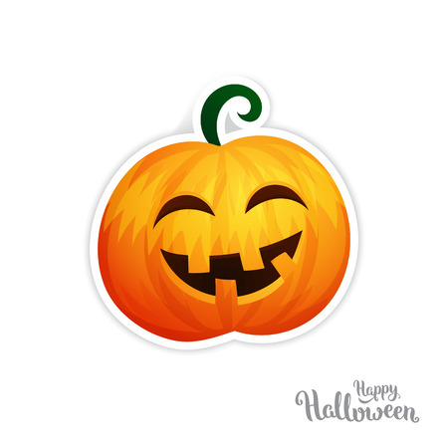

Go Card Distribution:

Students who did not get their Go Cards during last Connections class, please come to the office to get them.

Clubs and Activities

There are no clubs and activities announcements yet.

Athletics

There are no athletics announcements yet.

Important Upcoming Dates
Nov 1: Photo Retake Day
- Nov 2: Grade 9 Take Your Kids to Work Day
- Nov 2-3: Grad Assessments

