Grad Boat Cruise Map

Boat Cruise goes May 9th, 2024, from 7pm to 10pm.
Students will be taking a cruise around the Vancouver Harbour on May 9,2024
The 3-hour cruise includes food, pop, a DJ and beautiful views of the city.

Boarding at 6:30 pm.
Don't be late as the Boat will not wait and will leave without you at 7pm sharp.
Students MUST have a PRE-ARRANGED ride home for 10pm.

Dock B - Pacific Boulevard Marina
750 Pacific Boulevard, Vancouver

750 Pacific Boulevard, Vancouver
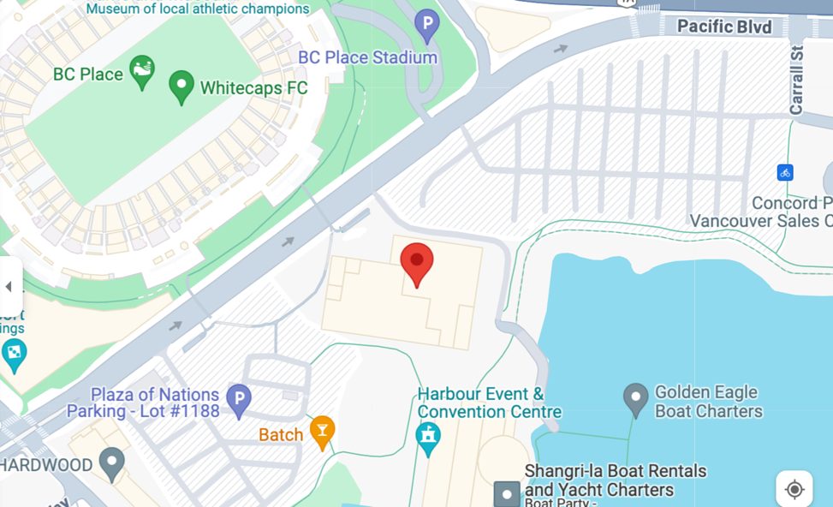

Dock B - Pacific Boulevard Marina
